**Sound meter**

## Step 1: Make it

### What is it?

Measure how noisy it is around you using the new micro:bit's microphone sensor and a simple bar chart display.

### What you'll learn

* How to use the new micro:bit's built-in microphone input sensor to measure how loud sounds are around you
* How to display numerical data from input sensors graphically on the LED display output

### How it works

* The new micro:bit's microphone measures sound levels in numbers between 0 and 255. 0 is the quietest and 255 is the loudest sound measurement it can make.
* The code uses a forever loop to keep the microphone measuring sound levels and plotting a bar graph on the LED display.
* The louder the sounds measured, the higher the bar graph gets.

### What you need

* new micro:bit with sound (or MakeCode simulator)
* MakeCode or Python editor
* battery pack (optional)

## Step 2: Code it

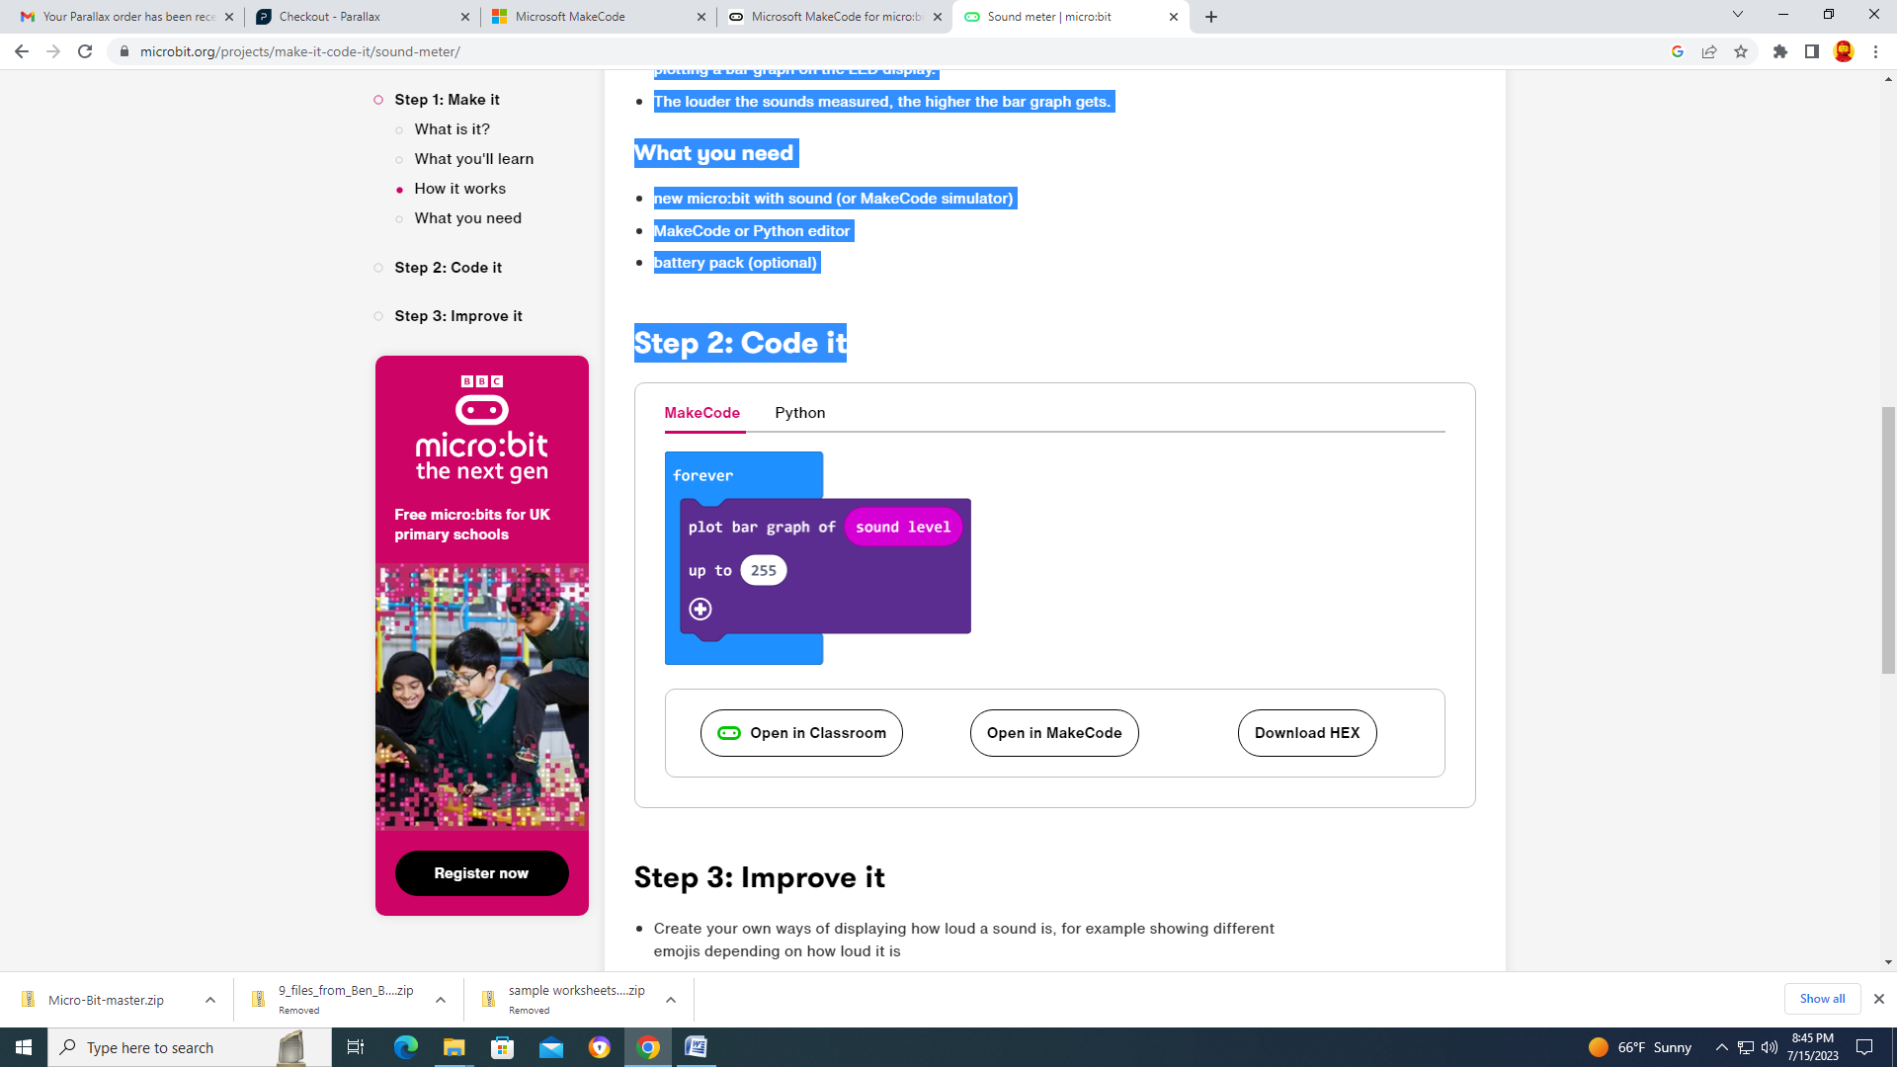

## Step 3: Improve it

* Create your own ways of displaying how loud a sound is, for example showing different emojis depending on how loud it is
* Make a visual noise alarm that only flashes when the sound goes over a certain level - you could use this to help keep your classroom peaceful